Least Connections

⚖️ What Is Least Connections in Load Balancing?
# Source: AI Source: Provided by: [Data Path: Persons Table -> ID Column: 1, Name_En Column: Motasem Essam] -> From: [ChatGPT] on [12/15/2025]
Least Connections is a load balancing method that sends each new request to the server that currently has the fewest active connections.
It helps distribute traffic more intelligently — especially when requests have different processing times.

✅ Simple Definition:
# Source: AI Source: Provided by: [Data Path: Persons Table -> ID Column: 1, Name_En Column: Motasem Essam] -> From: [ChatGPT] on [12/15/2025]
Least Connections chooses the server with the least number of users currently connected to handle the next request.

🧠 Real-Life Analogy:
# Source: AI Source: Provided by: [Data Path: Persons Table -> ID Column: 1, Name_En Column: Motasem Essam] -> From: [ChatGPT] on [12/15/2025]
Imagine 3 checkout lines at a store:
- One has 5 people
- One has 3
- One has 1
You go to the one with 1 person — that’s Least Connections in action.

🧪 Example:
# Source: AI Source: Provided by: [Data Path: Persons Table -> ID Column: 1, Name_En Column: Motasem Essam] -> From: [ChatGPT] on [12/15/2025]
Suppose 3 servers:
- 🖥 Server A: 10 active users
- 🖥 Server B: 5 active users
- 🖥 Server C: 2 active users
🔁 The next request will go to Server C (fewest connections).

🔍 Why Use Least Connections?
# Source: AI Source: Provided by: [Data Path: Persons Table -> ID Column: 1, Name_En Column: Motasem Essam] -> From: [ChatGPT] on [12/15/2025]
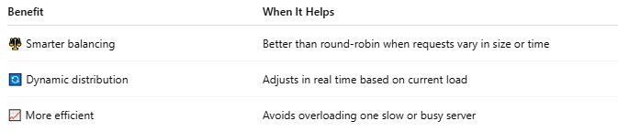

Benefit | When It Helps
⚖️ Smarter balancing | Better than round-robin when requests vary in size or time
🔄 Dynamic distribution | Adjusts in real time based on current load
📈 More efficient | Avoids overloading one slow or busy server

🧱 Nginx Configuration Example
# Source: AI Source: Provided by: [Data Path: Persons Table -> ID Column: 1, Name_En Column: Motasem Essam] -> From: [ChatGPT] on [12/15/2025]
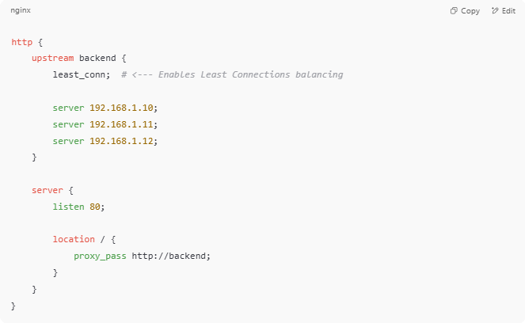

http {
upstream backend {
least_conn; # <--- Enables Least Connections balancing

server 192.168.1.10;
server 192.168.1.11;
server 192.168.1.12;
}

server {
listen 80;

location / {
proxy_pass http://backend;
}
}
}

⚖️ Least Connections vs Round Robin
# Source: AI Source: Provided by: [Data Path: Persons Table -> ID Column: 1, Name_En Column: Motasem Essam] -> From: [ChatGPT] on [12/15/2025]
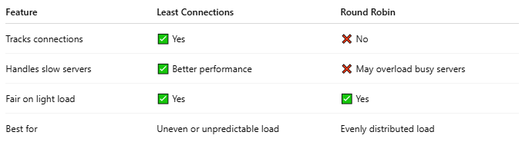

Feature | Least Connections | Round Robin
Tracks connections | ✅ Yes | ❌ No
Handles slow servers | ✅ Better performance | ❌ May overload busy servers
Fair on light load | ✅ Yes | ✅ Yes
Best for | Uneven or unpredictable load | Evenly distributed load

🧠 Example Use Cases
# Source: AI Source: Provided by: [Data Path: Persons Table -> ID Column: 1, Name_En Column: Motasem Essam] -> From: [ChatGPT] on [12/15/2025]
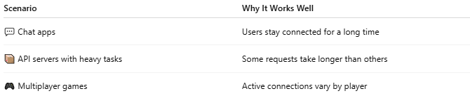

Scenario | Why It Works Well
💬 Chat apps | Users stay connected for a long time
📦 API servers with heavy tasks | Some requests take longer than others
🎮 Multiplayer games | Active connections vary by player

🔐 Tips for Using Least Connections
# Source: AI Source: Provided by: [Data Path: Persons Table -> ID Column: 1, Name_En Column: Motasem Essam] -> From: [ChatGPT] on [12/15/2025]
- Avoid if your requests are all the same size — Round Robin may be simpler
- Ensure health checks are enabled so dead servers aren’t considered
- Works best when connections last longer than a few milliseconds

📌 Summary
# Source: AI Source: Provided by: [Data Path: Persons Table -> ID Column: 1, Name_En Column: Motasem Essam] -> From: [ChatGPT] on [12/15/2025]


Feature | Description
🧠 Method | Chooses server with the fewest active connections
📊 Benefit | Distributes load based on real usage
⚙️ Used in | Nginx, HAProxy, AWS ELB, Apache, etc.

